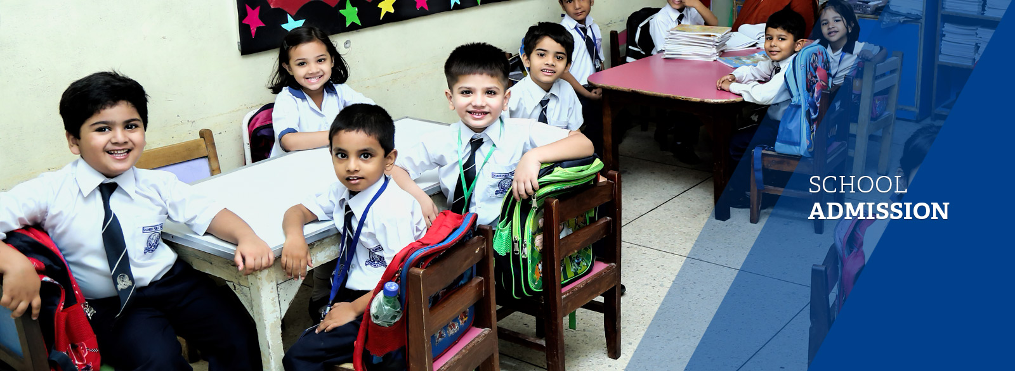

**SHAHEEN PUBLIC SCHOOL ADMISSION POLICY**

**REGISTRATION**

* **Parents seeking admission should first register their child and make an appointment to appear in the test.**
* **Registration does not in any way confirm or guarantee admission. Admission is subject to passing the admission test and the interview and the availability of space in the class..**
* **The class for which a child is tested is determined according to the child's age.**

**ASSESSMENT/ADMISSION TEST**

***Play House***

* **A formal interview with both the parents is taken. The child must also be present at the time of interview.**

***Montessori to Class IX***

* **Applicants for Montessori and onwards are tested in three subjects - English, Urdu, and Mathematics (for classes VIII and IX, Science is also included in the test).**
* **For the written test, the child should come properly equipped with the required stationary.**
* **The tests are of general nature, designed to assess the knowledge and understanding of the child in the core subjects.**
* **Successful students will appear for the interview.**
* **If the student passes the test and does well in the interview, the student is offered the admission. However, in all cases, the admission is up to the discretion of the school management.**

**ADMISSION PROCEDURE**

* **Parents will receive the admission fee voucher from the Account’s Office.**
* **The fee will be deposited at the relevant campus’s bank.**
* **Admission form is issued from the Admissions Office (to be filled at the school) after depositing the admission fee voucher.**
* **The child is permitted to attend classes only after receiving the admission confirmation from the Admission Office.**
* **To see the documents to be attached with the Admission Form, please click Admission Requirements.**
* **Any paid fee will not be refundable in case of cancellation.**
* **The fee is subject to annual review.**

**DOCUMENTS REQUIRED FOR ADMISSION IN SCHOOL**

***PlayHouse till Class VIII***

* **Admission Form**
* **NIC photocopy of the parents**
* **NADRA B-Form or Birth certificate copy**
* **4 pictures of the child**
* **Paid Voucher**

***IX and X / Matric Board Karachi***

* **Admission Form**
* **NIC photocopy of the parents**
* **NADRA B-Form**
* **16 pictures in uniform of the child**
* **Voucher**
* **Consent Form**

***O-Level / Cambridge***

* **Admission Form**
* **NIC photocopy of the parents**
* **NADRA B-Form**
* **12 pictures in uniform of the child**
* **Paid Voucher**
* **Consent Form**
* **Photocopy of Provisional Certificate**

**RULES OF PAYMENT**

* **Fees are charged for all twelve months of the academic year (April to March) and are payable monthly within the given due date.**
* **The fees payable for the period of the summer vacation are paid in advance and before closure of the school for summer vacation.**
* **Once the fee voucher is issued, payment is made directly to the bank where the school operates its account. Parents must pay the fees by the date specified on the fee voucher.**
* **Fees paid after the due date is subject to a late fee as specified on the fee voucher.**
* **If the tuition fee is not paid by the end of the second month, the student’s admission will be canceled and will not be allowed in school**

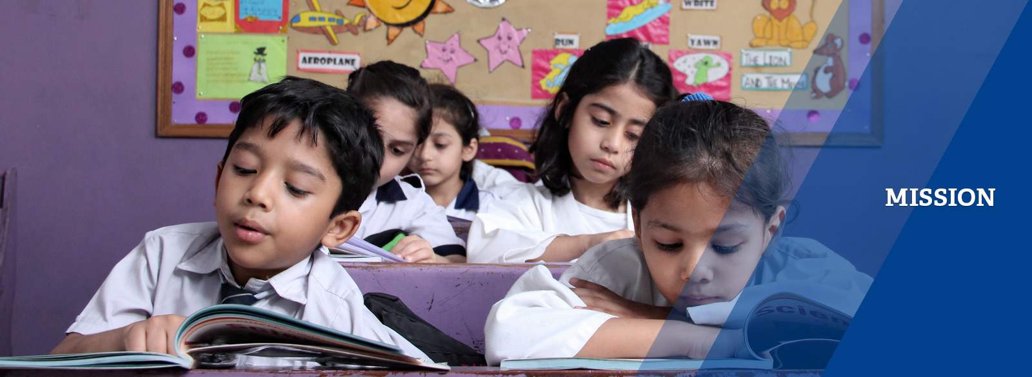**At Shaheen public school and college, we are committed to providing worldclass education and learning environment in which all students achieve the very best academically, physically and socially. We challenge and inspire each student to achieve their dreams and to become a passionate learner, preparing them to adapt and contribute to a rapidly changing, highly competitive global society.**

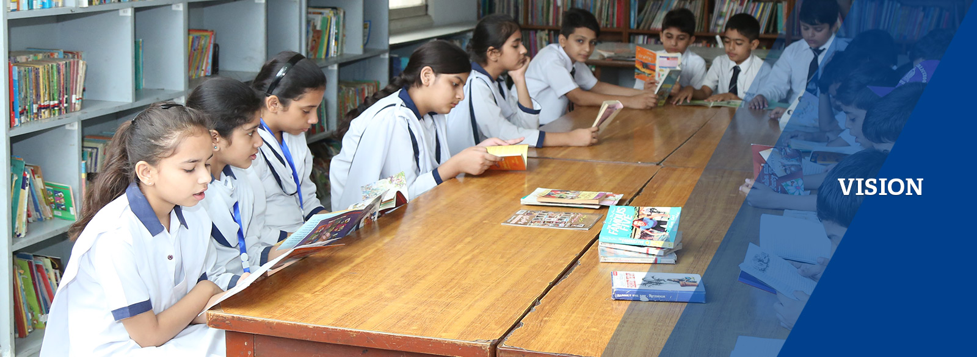**To be a leader in education by empowering all our students to become engaged, caring and valuable citizens of the ever-changing, unpredictable world by providing exceptional teachers and a diverse range of academic and extracurricular choices, in a safe and welcoming environment.**

**TRANSPORT**

**The transport system offers safe and secure transport facility for very young children by ensuring that the vans used for this purpose are well maintained, drivers are experienced, and maids are present to look after the children in the vans.**